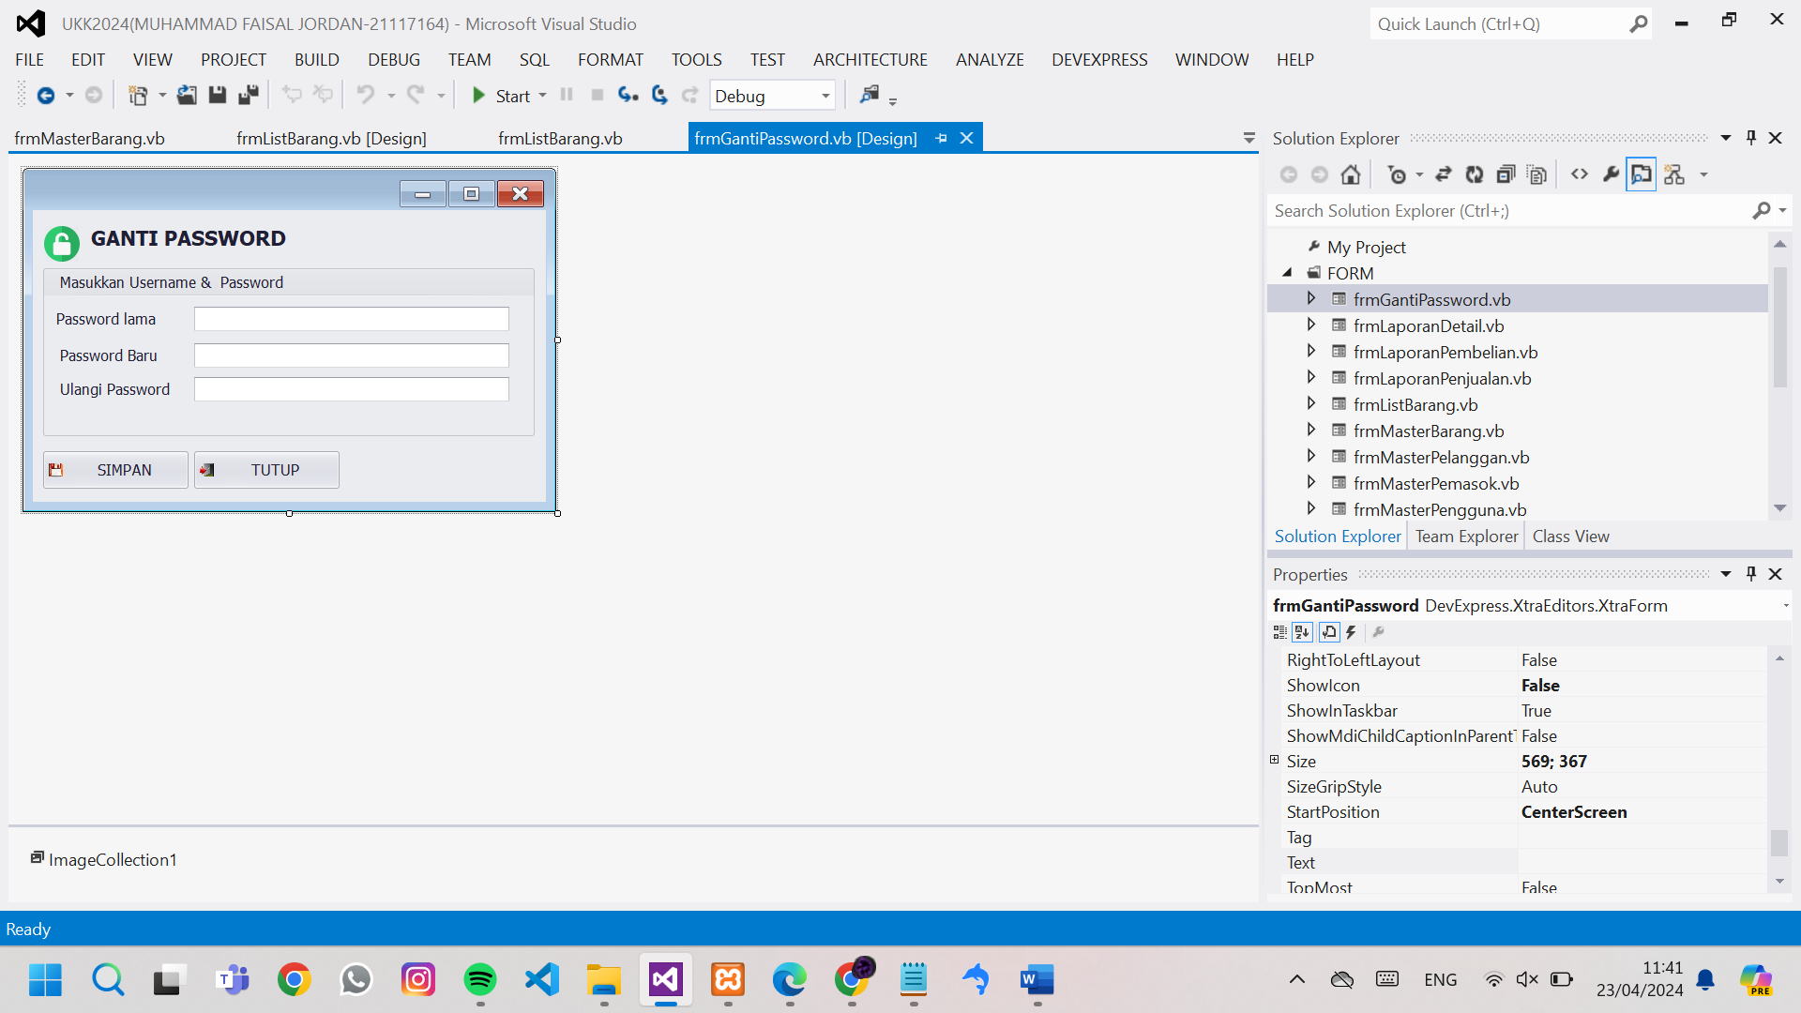

Public Class frmGantiPassword

Sub Simpan()

'memastikan semua inputan terisi

If txtPasswordLama.Text = "" Or txtPasswordBaru.Text = "" Or txtUlangiPassword.Text = "" Then

MessageBox.Show("Password Lama, Password Baru dan Ulangi Password Wajib Di Isi!", "Comfirm", MessageBoxButtons.OK, MessageBoxIcon.Warning)

Exit Sub

End If

'mencocokan password lama

Dim PasswordLama = EksekusiSQL("select password from pengguna where ID_PENGGUNA ='" & My.Settings.lgnID & "'").Select()(0).Item("PASSWORD")

If txtPasswordLama.Text <> PasswordLama Then

MessageBox.Show("Password yang anda tidak sesuai!", "Comfirm", MessageBoxButtons.OK, MessageBoxIcon.Warning)

End If

'mencocokan password baru

If txtPasswordBaru.Text <> txtUlangiPassword.Text Then

MessageBox.Show("Password Baru tidak sesuai!", "Comfirm", MessageBoxButtons.OK, MessageBoxIcon.Warning)

End If

'mengubah password lama menuju password baru

EksekusiSQL("update pengguna set PASSWORD ='" & txtPasswordBaru.Text & "' where ID_PENGGUNA = '" & My.Settings.lgnID & "'")

'kembali ke login

frmSetupLogin.Show()

frmSetupMenuUtama.Close()

Me.Close()

End Sub

Sub Tutup()

Me.Close()

End Sub

Private Sub frmGantiPassword_KeyDown(sender As Object, e As KeyEventArgs) Handles Me.KeyDown

Select Case e.KeyCode

Case e.Control And Keys.Enter

Simpan()

Case Keys.Escape

Tutup()

End Select

End Sub

Private Sub FormGantiPassword_Load(sender As Object, e As EventArgs) Handles MyBase.Load

Me.KeyPreview = True

txtPasswordBaru.Properties.UseSystemPasswordChar = True

txtPasswordLama.Properties.UseSystemPasswordChar = True

txtUlangiPassword.Properties.UseSystemPasswordChar = True

txtPasswordLama.Text = ""

txtPasswordBaru.Text = ""

txtUlangiPassword.Text = ""

txtPasswordBaru.Focus()

End Sub

Private Sub SimpleButton1_Click(sender As Object, e As EventArgs) Handles SimpleButton1.Click

Simpan()

End Sub

Private Sub SimpleButton2_Click(sender As Object, e As EventArgs) Handles SimpleButton2.Click

Tutup()

End Sub

End Class